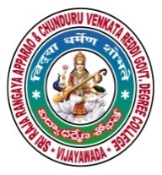 | SRR & CVR GOVERNMENT DEGREE COLLEGE  (AUTONOMOUS)  VIJAYAWADA, KRISHAN DIST., A.P  NAAC B+GRADE(CGPA:2.60) | 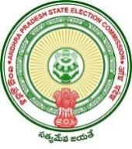

Jashuva Jayanti
Date: 28-9-2021
- Fresher’s day celebrations on SRR & CVR college (A), Vijayawada

- Resource person: HOD’s of all departments and respected Lecturers .

- Chief Patron: Principal Dr. Bhagya Lakshmi and Dr.M.Anthoni.

- Events: Senior students welcomed fresher’s with their cultural participation in various live events like singing, dancing and poetry.

ashuva Jayanthi was celebrated on 28/9/2021 in SRR and CVR GDC(A), VJA. Our principal madam, Dr. K. Bhagya Lakshmi was the Chief guest and spoke about the greatness of Jashuva and his Poetry. She also spoke about the Jashuva’s poetry influence on Telugu Literature and the society. The entire program was organized by Telugu department and some of the lecturers talk about the significance of Jashuva’s poetry. Some of the students also read their own poems. Many Students were motivated to read Jashuva’s poetry.

